lAB TASK

**Muhammad Umer Mukhtiar SP20-BSE-055 Sohail Sadiq SP20-BSE-073 Usman Toufiqe SP20-BSE-046**

Software project management

**COMSATS University Islamabad, Abbottabad Campus

**Department of Computer Science**

**Software Project Management**

**Lab Assignment 3**

**GRADED 10 MARKS**

**Question:**

* **Submit the functional requirements for your selected project.**
* User shall upload their CV’S
* System Generated passwords shall use for accessing profile of employee
* Accounts shall be verified by admins
* Any user can use abusive language in feedback account should be temporary ban and filters shall use in backend to stop or put that feedback on pending until reviewed by admin
* Content user want to share with employer will be visible between user and employer and make sure data shall be able to open through system generated code .
* **Submit the non-functional requirements for your project.**
* Each page shall open within 1 second of tap on button and upload process with low latency with server.
* The profile of each user shall be confidential and safe in system by his/her password and email.
* The user demanding to increase storage space shall be given a monthly plan to upgrade their storage in system.
* System shall be low end friendly which means it can be opened on any low-end devices
* Interpretability
* The system will not damage or lose data of user if a crash happens as it operates with real time saving environment.
* User shall not wait too long for a file to upload or download a file from server.
* System shall not exceed the maximum storage provided to user for uploading documents and images.
* User shall get a welcome message and a tutorial guide for the use of website after logging in to the system.
* The website shall load in less than 2 seconds if the users profile’s data is less than 100Mbs.
* **Submit the Use Case Diagram for your Selected Project**

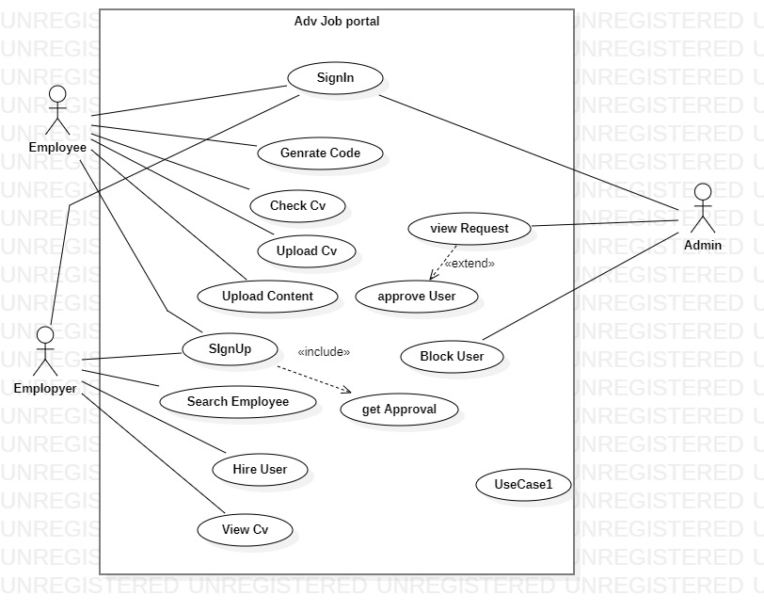

* **Submit Use Cases detail in Fully Dressed Format.**

|  |  |
| --- | --- |
| Name | Login |
| Scope | Job Portal App |
| level | User Goal |
| Primary Actor | Employee, Employer |
| Stake Holder and Interests | **Employee**: - Have Account to Set Profile and add more information to show more attractive view of profile.  **employer: -**Have Account to Set Profile and share info about required work.  -**App**:- Application requires the information to approve the account to register |
| preconditions | 1. User Login 2. Greet with Dashboard. 3. Go to Menu 4. Click on Set Profile 5. Enter Required information in Text fields 6. Select right options from combo boxes 7. Click on upload profile 8. Select picture and Upload 9. Click on save changes 10. Changes are applied on profile successfully |
| Post Condition | give required Information in text Fields select options from combo boxes(Education , skills, country code) and upload profile picture |
| Main Success Scenario | Save changes Successfully and Profile Updated. |
| Extension | * In case of giving wrong information or try to use fake name or less than 10 digit number dialog box appeared with warning * user do not give bio red text is appeared in text area. * user does not select country code dialog box will be appeared with warning * user do not select any skill dialog box appeared with warning * user select more than 1 pic profile picture could not be changed. * any other format file or pic selected like pdf, docx etc. profile pic will not be changed * mandatory fields are empty dialog box appeared with message. |
| Special requirements | **User name ,password** |

|  |  |
| --- | --- |
| Name | Hire Employee |
| Scope | Job Portal App |
| level | User Goal |
| Primary Actor | Employer |
| Stake Holder and Interests | **-**Employer: -hire employee for required work. |
| preconditions | enter required skill name in search bar. |
| Post Condition | * show all employees according to search or relevant skill. Enter skill in search bar |
| Main Success Scenario | * User Login * Greet with Dashboard. * Go to Menu * Enter skill in search bar * Click on search button * Click on employee name * Profile previewed * Click on Hire button * Dialog box appeared with message “request forwarded successfully”. |
| Extension | If no result found against skill dialog box appeared with message of no result found |
| Special requirements | **User name** |

|  |  |  |
| --- | --- | --- |
| Name | | Upload Document |
| Scope | | **Job Portal App** |
| level | | User Goal |
| Primary Actor | | Employee |
| Stake Holder and Interests | | **-Admin**:- wants the documents to approve the profile and level up.  -**Employer**:- Needs to see the work and achievement of candidate to hire.  -**App**:- Application requires the educational data in documents to approve the profile to register |
| preconditions | | Browse for document. Candidate will be required to upload the document in order to maintain a public profile. |
| Post Condition | | Document published to share with Employers or Anyone with share code. |
| Main Success Scenario | | * User Logins * System Greets with dashboard * User selects the documents section * Click Upload Button * Upload Dialog appears * Selects Docx Files * Upload file or can select multiples * 8. File is Uploaded and shown in documents sectio**n** |
| Extension | | In case User selects the file of other format than .docx or pdf file the system rejects the file and file is not uploaded.  User has to publish the document after uploading to profile to make it visible to the person reviewing the file.  If User cancel the upload, it goes back to the Document section. |
| Special requirements | Docx or pdf file Requires  -File size not be greater than 2mb  -Documents needed with educational information and work experiences in file forms. | |

|  |  |
| --- | --- |
| Name | Generate Code |
| Scope | **Job Portal App** |
| level | User Goal |
| Primary Actor | Employee |
| Stake Holder and Interests | -**Candidate**:- To share his work to public share code is needed  -**Employer**:- To hire someone and review profile the code is required to enter. |
| preconditions | Someone want to see your data you just click on generate code and send generated link to person or company who wants . |
| Post Condition | Employers are able to see Candidates work experience and Profile**.** |
| Main Success Scenario | * User logins * User Clicks the share code button on dashboard. * Code is generated as password to cloud * Code copy option is visible * User sends the Code to employer * Employer can use the Code to review profile or Hire. * 7. Code is expired after 2 mins of generation. |
| Extension | * Code not opened in 2 mins it expires and shows nothing on click. * Code cannot be opened more than one time for one employer. * If Employer does not open link it expires * 4. New link is generated and old is destroyed if user generates a new one. |
| Special requirements | * Code must be generated and then copied too in 2 mins. * Copied Code should be a small URL. * Two generated Code cannot be same. * -Employer gets only viewing access to profile by Code |

|  |  |
| --- | --- |
| Name | Job Portal App |
| Scope | Job Portal App |
| level | User Goal |
| Primary Actor | Employee |
| Stake Holder and Interests | Employer:- It is necessary to create an account to use the portal.  -Employee:- It is necessary to create an account to use the portal for hiring employees.  -App:- Application requires the information to approve the account to register |
| preconditions | Candidate will be required to give the information in order to create register account and maintain a public profile. |
| Post Condition | After giving information it will be updated to user profile and will be save on public server . |
| Main Success Scenario | * Open Portal * Click on Signup * System Greets with Signup Window * User fill the required fields * Select the required options * Accept terms And Conditions * Click on Submit. |
| Extension | * If user want to use single email for multiple accounts dialog box will be shown with warning * In case user given name is already existed suggestions of names will be shown * If user not accept terms and conditions submit button will be disabled until user agree to terms and conditions * In case User miss to filled the mandatory text fields. Process could not be gone forward and show red text in text fields until they will be filled |
| Special requirements | • 8-digit Password  • E-mail  • Accepting Terms and conditions. |